Deliverable #2 - "Software Design Specification Document" Outline
- Introduction
  - Purpose of this document
  - Any changes to previous plan

- Architectural Design
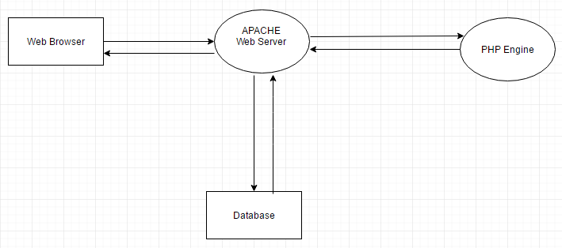

- User Interface Design
  - Updated input screens
  - Updated output screens

- Component Design (for each module)
  - Processing Narrative / Flowchart – Diagram of classes in boxes with arrows pointing to other classes that they interact with. Along these line are written the functions that allow them to interact.
  - Interface Description

- Data Design
  - Updated Class diagrams – Update from first deliverable and copy and paste here.

Data Dictionary

Field Name | Caption | Data Type | Field Size | Notes
CEMAIL | Customer Email | Varchar | 40
CNAME | Customer Name | Varchar | 20
PHONE | Phone Number | Varchar | 15
Entity: OurCustomers This table contains Information about our customers

Entity: OurProducts This table contains Information about our products

Field Name | Caption | Data Type | Field Size | Notes
PNO | Product Number | Varchar | 6
PNAME | Product Name | Varchar | 30
QOH | Quantity on hand | Int | 11
IMG | Image | Blob
PRICE | Price of item | Int | 11
DIMENSIONS | Dimensions of item | Varchar | 10
MEDIUM | Medium of paint | Varchar | 50 | Materials-Used

Entity: OurDetails This table contains information about the the products on hand

Field Name | Caption | Data Type | Field Size | Notes
ONO | Order Number | Int | 11
PNO | Part Number | Varchar | 6
QTY | Quantity | Int | 11

Entity: OurOrders This table contains information about our orders

Field Name | Caption | Data Type | Field Size | Notes
ONO | Order Number | Int | 11
CEMAIL | Customer email | Varchar | 40
RECEIVED | The date ordered | date
SHIPPED | The date shipped | date

Entity: LivesAt. This table contains information about the addresses of our customers since customers can have multiple address for shipping.

Field Name | Caption | Data Type | Field Size | Notes
CEMAIL | Customer Email | Varchar | 40
STREETADD | Street address | Varchar | 30
ZIP | Zip codes | Varchar | 6
CITY | City | Varchar | 20
CSTATE | Customer State | Varchar | 30

ER Diagram:

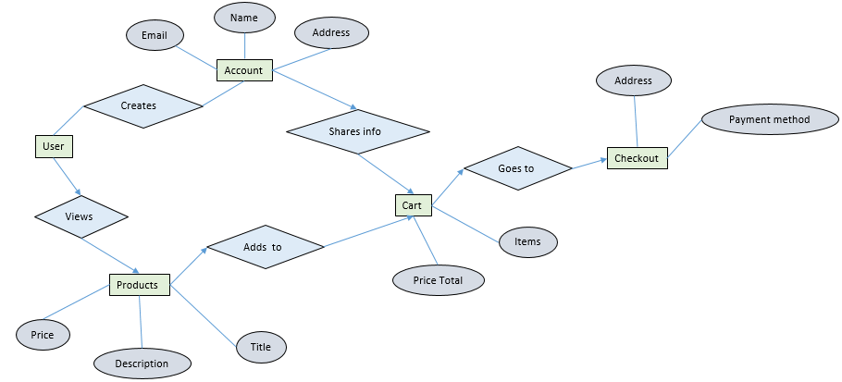
- Change Request Form
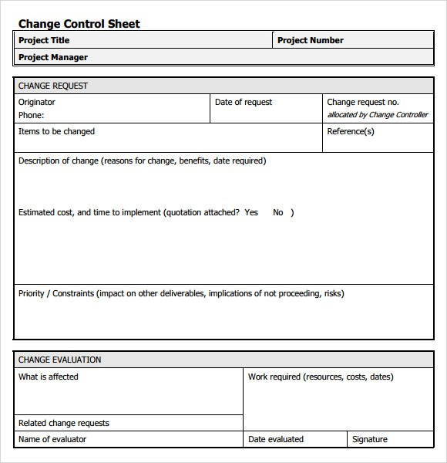

- Test Plan

Test ID | Description | Test Data |  | Expected Result | Actual Result | Pass/Fail
001 | Create user,  Nonexistent email | 'Charles@gmail.com','Charles','316-636-555', '4581 Cherry Street','67226','Wichita', 'Kansas',’Password123’ |  | Valid
002 | Create user,  Existing email | 'Charles@gmail.com','Charles','316-636-555', '4581 Welsh Street','67226','Wichita', 'Kansas',’Password123’ |  | Invalid
003 | Create user,  Invalid email address | ‘CranberryMoonwalk@gmail’,’Bob','316-636-555', '4581 Welsh Street','67226','Wichita', 'Kansas',’Password123’ |  | Invalid
004 | Login  Existing user, correct password | ‘Charles@gmail.com’,’Password123’ |  | Valid
005 | Login Existing user, incorrect password | ‘Charles@gmail.com’, ’NotTheRightPassword’ |  | Invalid
006 | Login Non-existing user/incorrect email | ‘ImNotCharles@gmail.com’,’Password123’ |  | Invalid
007 | Order, existing user | (image1,'Charles@gmail.com','1994-12-10','1994-12-12') |  | Valid
008 | Add to cart, existing user,  Product sold out |  | (image1,'Charles@gmail.com','1994-12-10','1994-12-12') | Invalid
009 | Search existing product | (image8) |  | Valid
010 | Search nonexistent product | (image40) |  | Invalid
011 | Boundary Test for create user with email, email length:  Min – 1  Max - 40 | (@gmail.com)  (‘a@gmail.com’)  (‘ThissEmailcontains40characters@gmail.com’)  (‘ThisssEmailcontains41characters@gmail.com’) |  | Invalid  Valid  Valid  Invalid

- We are using Github.

- Updated MS Project Reports

- Project Meeting Notes:

  - Things are progressing smoothly. Everyone attends the group meetings and provides valuable input. Everyone has followed through with their tasks thus far.

